Guidance for Reporting of PV Data Using the Updated PV Data Reporting Tools
Effective 9 March 2026

This guidance is applicable to Internal Staff and Services Providers working in
Patient Programs, Market Research, Digital Properties, and General Services to which PV Requirements apply

- PV Data reporting when using the forms:
Internal staff and Services Providers who were using forms to report PV Data before March 9th, 2026 are required to continue to report PV Data using forms, unless otherwise instructed by Sanofi PV.
From March 9 onward, the two forms to be used are:
Solicited Individual Safety Information (ISI) Collection & Documentation Form_V 2.0_ 9 Mar 2026 (Solicited ISI form)
Spontaneous Individual Safety Information (ISI) Collection & Documentation Form_V 2.0_ 9 Mar 2026 (Spontaneous ISI form – Spontaneous is also referred to as Unsolicited)

Unless otherwise instructed by Sanofi PSPV,
-the SOLICITED ISI form is to be used to report PV data collected in Patient Programs and Market Research
-the SPONTANEOUS (UNSOLICITED) ISI form is to be used to report PV data collected in Digital Properties and in General Services
The completed form should be sent by email to the global generic email address, whatever the language of completion:
PV-ARTEMIS-SANOFI@IQVIA.COM
If your email signature contains a logo, the logo needs to be removed before sending the email.
You will receive an acknowledgement of receipt containing a unique INBOX ID, and the subject line of your initial submission.

- Acknowledgements of receipt must be kept on file.
- If you do not receive an acknowledgement of receipt, the report should be resent as soon as possible and no later than one (1) business day.

- PV Data reporting when using Sanofi PV Artemis Portal (PV Portal):

Internal staff and Service Providers who were using the PV Portal to report PV Data before March 9th, 2026 are required to continue to report PV Data via the PV Portal unless otherwise instructed by Sanofi PSPV.
The link to the PV Portal remains unchanged: Sanofi PV Artemis Portal.
At the time of the first report, Portal users must self-register to create an account (“sign up”) and then access the PV Portal with the “sign in” option.

Note: All existing accounts will remain active in the new PV Portal version.

Main advantages of registering to the PV Portal
As contact information is provided at time of registration, this contact information (including e-mail address used for acknowledgement of receipt, name, address, etc.) will be auto-populated in the Contact Details section of the PV Portal for every subsequent report of safety information.
Registered users have access to a dashboard where they can see and retrieve the reports they previously submitted via the PV Portal and they are able to add incoming follow-up data in existing registered cases.
For corrections to a previously submitted report, registered users can retrieve the report in the dashboard and correct the data as needed.
In the “Patient” section, go to the field “Please describe all information associated to the reported safety information/side effect (all signs and symptoms, possible causes and progression)”, add the statement: “Correction to previously submitted report” along with details of the correction (e.g., “Correction to previously submitted report – Revised the unique patient ID”). Submit the report.

The PV Portal fields titles are available in English, French, and a few other languages but individual fields can be completed in any language.

How to register:

- Follow the link to the PV Portal.
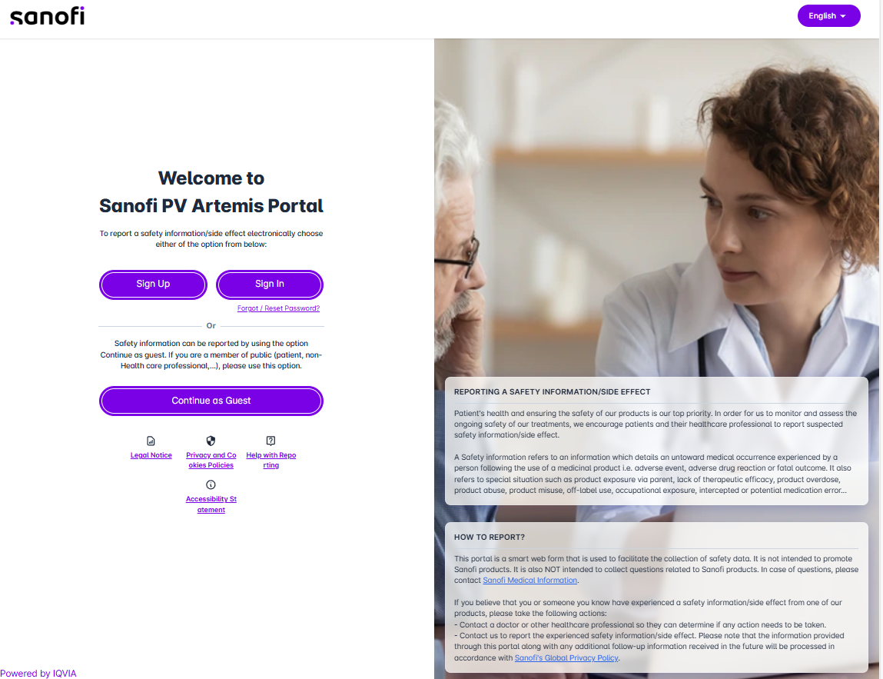

- At the time of the first connection select Sign Up

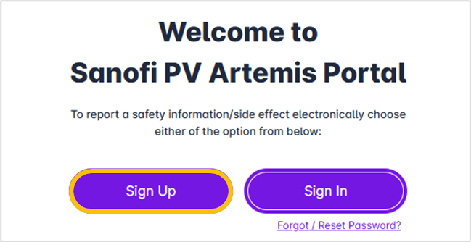

- Complete all the fields with a special attention to the following:
Type of User: Select “Health Care Professional or Service Provider or Non PV Sanofi Employee”
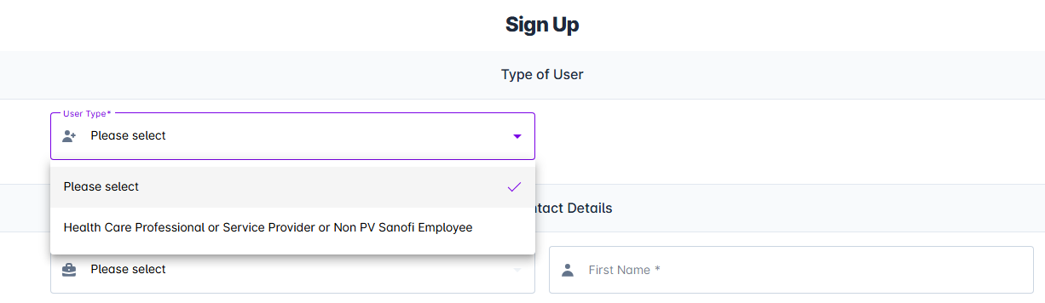

Other contact Details:
In “Profession” select “Service Provider”.
In Name of hospital, clinic, organization enter the name of your company.

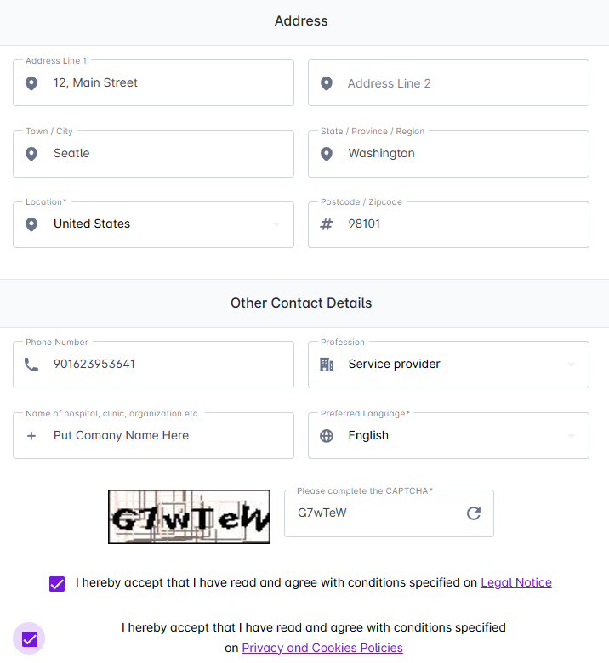

- Once all the fields are completed, click on Submit



- After submission, you will receive the email below which contains an activation link. Before you can sign in for the first time to report safety information, you will have to activate your account by clicking the “click here” link in the email.

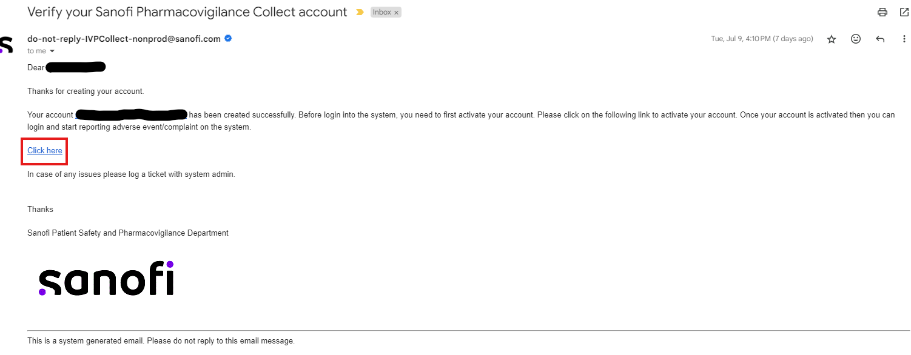

Congratulations! You are now ready to report PV Data to Sanofi via the PV Portal!

Sign In using your credentials.

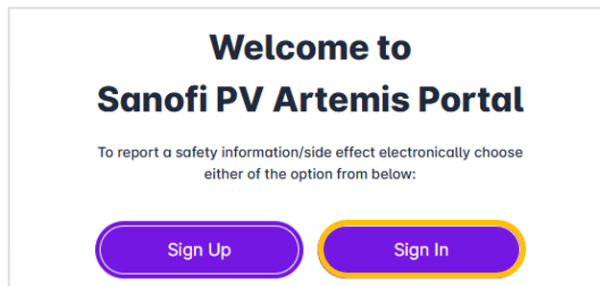
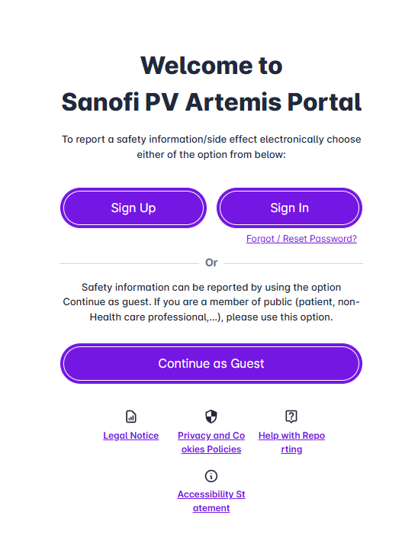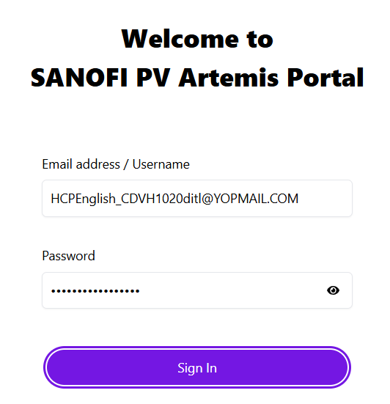

When you sign in, you have access to a dashboard where you can see and retrieve the reports you previously submitted via the PV Portal.
To submit new safety information, click the Report Initial Case button at the top right of the page:
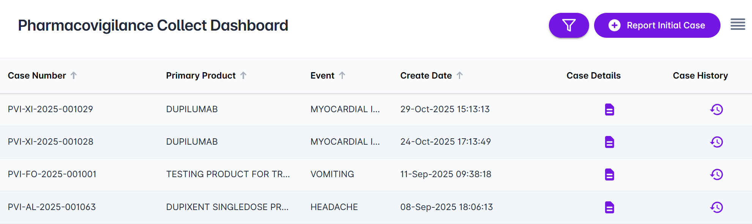
This will take you to a series of tabs where you can enter all the relevant details and data related to your safety report.
Be time conscious! You will receive a “Time Out” warning after 30 minutes of inactivity.
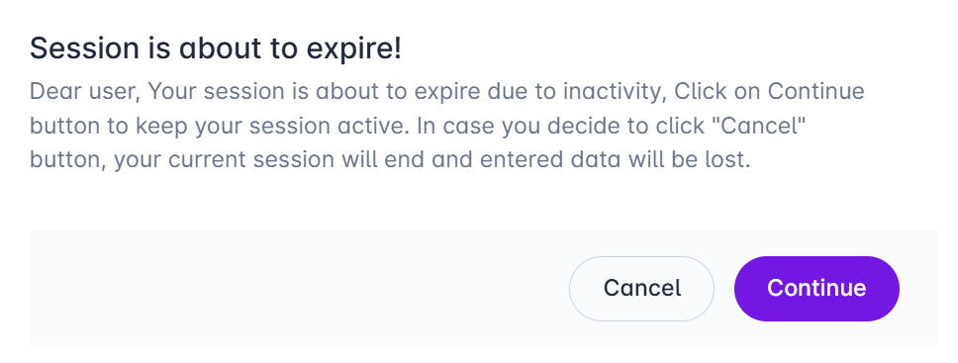
You can provide your password to continue with the report:
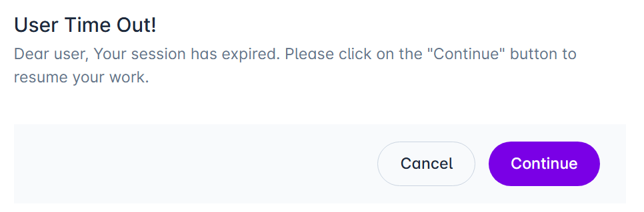

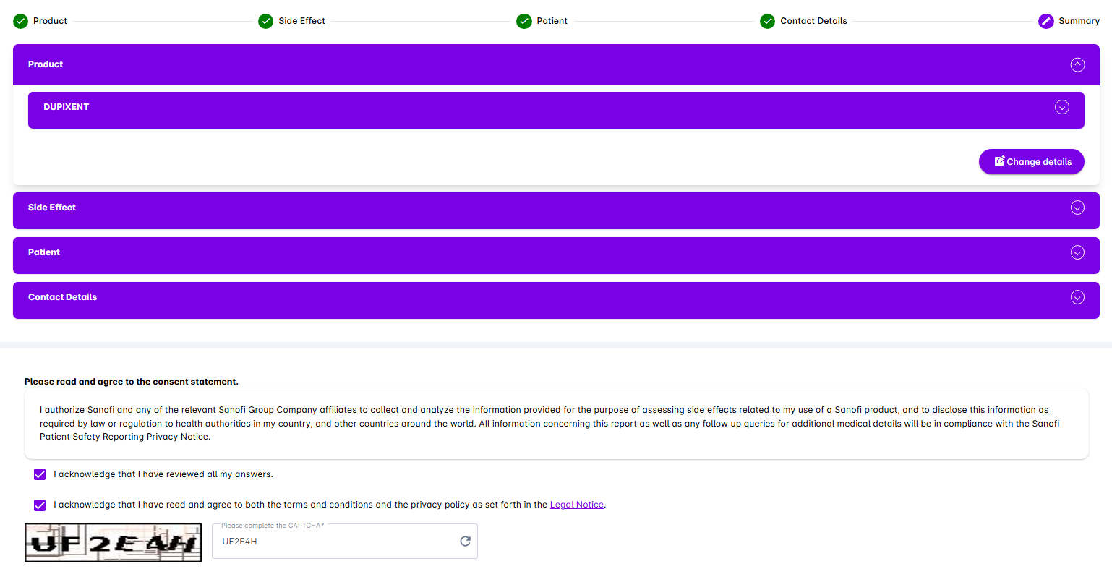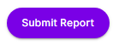

Thank you for your contribution to patient safety!

